THE CRYOTEC METHOD
Manual
For Oocytes, Embryos And Blastocyst Vitrification



Ph:+919819855905 ; +91 9821618106
Email: info@cryotechindia.com
www.cryotechindia.com

VITRIFICATION

PART 1 - Materials Required

- Cryotech Vitrification Kit
Equilibration Solution (ES): 1 vial of 1.0 ml
Vitrification Solution (VS): 2 vials of 1.0ml
4 Cryotecs
3 Vitri Plates with 3 wells each
- Microscope (Turn off the heating plate)
- Stop watch (with count up function)
- Tweezers
- Micro pipette for 300μl
- Cooling Rack
- Liquid Nitrogen

Note: Solutions to be used within 30 days of opening the vials. Sterile aseptic conditions of dispensing should be maintained.
PART 2 – Preparation for Vitrification

- Bring ES and VS vials to room temperature (25~27°C)
atleast 1 hour before vitrification.

- Write information of oocyte/embryo on the handle of Cryotec, and set on Vitri Plate (Fig.1).

Fig 1. Vitri Plate with Cryotec

- Fill 90% of the cooling rack with fresh liquid nitrogen

- Take the culture dish containing oocyte/embryo out from the incubator. Check the quality of the oocyte, embryo or blastocyst.

Note:
Use a right size pasteur pipette.
・140-150 μm for oocyte and cleavage stage embryo.
・160~200 μm for blastocyst.
For oocyte vitrification take the cumulus cells off.
Best timing of vitrification of blastocyst: the size (diameter) should be between160~220 μm for perfect survival after vitirfication.
PART 3 – Equilibration (12 – 15 min)

- Write ES, VS1 and VS2 on the lid of the Vitri plate. Fill the wells of Vitri Plate with 300μl ES, 300μl VS1 and VS2, respectively (Fig. 2). Put the lid on the Vitri Plate immediately.
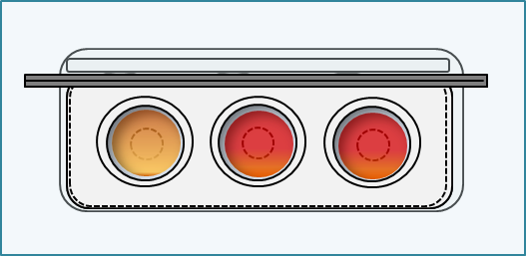

VS1
VS2
BS

Fig. 2. Preparation of Vitri Plate solution

- Aspirate the oocyte/embryo at the middle of the fine part of a pasteur pipette.
ES

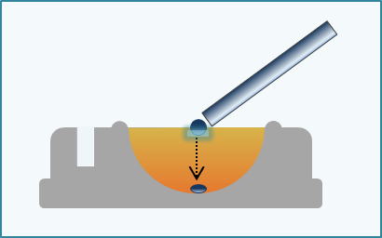
- Put the oocyte/embryo with small amount of medium on the surface of ES well. Start the stopwatch. As oocyte /embryo sink to the bottom, it will shrink (Fig. 3).

Fig. 3. ES Equilibration

- Put the lid and wait for the recovery of the shrinkage. When the oocyte/embryo volume is completely recovered, it is the end of this step. If you can’t confirm the complete recovery, the limit time of this step is 15 min for oocyte and blastocyst (160-200 μm in diameter), and 12 min for 4 -8 cells embryo.
PART 4 – Vitrification Step in VS1 (30 – 40 sec)

- Aspirate the oocyte/embryo with ES till the middle of the pipette. Transfer the oocyte/embryo at the middle depth of VS1 with ES (Step 1).
③

- Expel the remaining ES outside the well (Step 2/1) and aspirate fresh VS1 from the edge of the wall (Step 2/2).
Oocyte/embryo floats immediately to the surface of VS1 (Step 2/3).

- Aspirate oocyte/embryo at the top inside of pipette. Transfer it again to the bottom of VS1 (Step 3).

- The oocyte/embryo floats slowly to the middle depth and stops (Step 4).

- Expel the remaining VS1 outside the well, and aspirate fresh VS2. Aspirate oocyte/embryo at the top inside of the pipette.

VS1
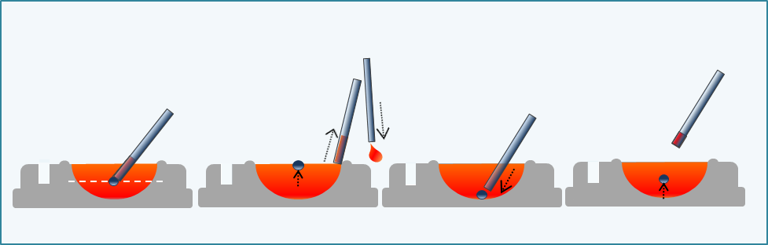
1
2
4
3
Fig. 4. VS 1 washing of oocyte/embryo (Step 1 – 4)
②

PART 4 – Vitrification Step in VS2 (10 – 20 sec)

- Transfer the oocyte/embryo to the middle depth of VS2 (Step 5).

- Expel the remaining VS outside the well (Step 6/1) and aspirate fresh VS2 from the edge of the wall (Step 6/2).

- Expel VS2 around the oocyte/embryo and mix the solution around oocyte/embryo to exchange the remaining previous solution (Step 7). Expel and wash inside of the pipette with fresh VS2.

- Take oocyte/embryo at the top of pipette (Step 8).

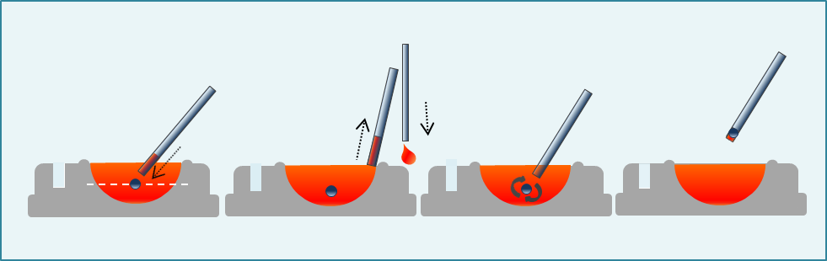
VS2

5
6
8
7

Fig. 5. VS2 washing of oocyte/embryo (Step 5 – 8)

①

PART 5 – Loading Cryotec

- Place the oocyte/embryo near the end of Cryotec sheet with minimal volume of VS2. (1 oocyte/embryo per droplet is recommended) (Fig. 6). Immediately submerge the Cryotec into fresh liquid nitrogen.
- Put the straw cap on Cryotec in the liquid nitrogen.

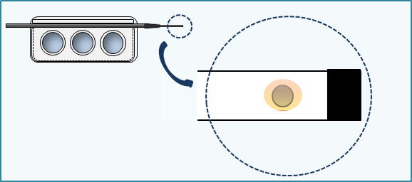

Fig. 6. Oocyte/embryo on the Cryotec

Note: 1 cryotec stores upto 3 oocytes/embryos

